**\*\*\*\*\*\*\*\*\*\*\*\*\*\*\*Severity and Priority:-**

**Bug Severity**

**Bug Severity** or Defect Severity in testing is a degree of impact a bug or a[Defect](https://www.guru99.com/defect-management-process.html)has on the software application under test. A higher effect of bug/defect on system functionality will lead to a higher severity level. A[Quality Assurance](https://www.guru99.com/all-about-quality-assurance.html)engineer usually determines the severity level of a bug/defect.

**What is Priority?**

Priority is defined as the order in which a defect should be fixed. Higher the priority the sooner the defect should be resolved.

Defects that leave the software system unusable are given higher priority over defects that cause a small functionality of the software to fail.

**KEY DIFFERENCE**

* Priority is the order in which the developer should resolve a defect whereas Severity is the degree of impact that a defect has on the operation of the product.
* Priority is categorized into three types : low, medium and high whereas Severity is categorized into five types : critical. major, moderate, minor and cosmetic.
* Priority is associated with scheduling while Severity is associated with functionality or standards.
* Priority indicates how soon the bug should be fixed whereas Severity indicates the seriousness of the defect on the product functionality.
* Priority of defects is decided in consultation with the manager/client while Severity levels of the defects are determined by the QA engineer.
* Priority is driven by business value while Severity is driven by functionality.
* Priority value is subjective and can change over a period of time depending on the change in the project situation whereas Severity value is objective and less likely to change.
* High Priority and low severity status indicates, defect have to be fixed on immediate bases but does not affect the application while High Severity and low priority status indicates defect have to be fixed but not on immediate bases.
* Priority status is based on customer requirements whereas Severity status is based on the technical aspect of the product.

**Tips for determining the Severity of a Defect**

* **Decide the frequency of occurrence:** In some cases, if the occurrence of a minor-defect is frequent in the code, it can be more severe. So from a user’s perspective, it is more serious even though it is a minor defect.
* **Isolate the defect:** Isolating the defect can help to find out its severity of the impact.

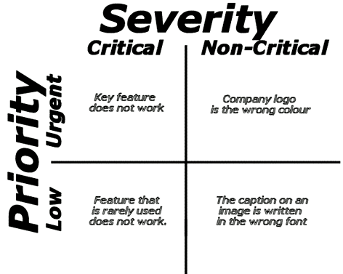

**Example of Defect Severity and Priority**

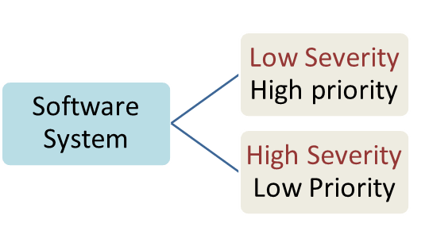

Let see an example of low severity and high priority and vice versa

* **A very low severity with a high priority:** A logo error for any shipment (Transport) website, can be of low severity as it not going to affect the functionality of the website but can be of high priority as you don’t want any further shipment to proceed with the wrong logo.
* **A very high severity with a low priority:**Likewise, for flight operating website, a defect in reservation functionality may be of high severity but can be a low priority as it can be scheduled to release in a next cyc**le.**

**\*\*\*Severity vs Priority : Key Differences**

|  |  |  |  |
| --- | --- | --- | --- |
| **Sr.No** | | **Severity** | **Priority** |
| **1** | Defect Severity is defined as the degree of impact that a defect has on the operation of the product | | Defect Priority has defined the order in which the developer should resolve a defect |
| **2** | Severity is categorized into five types   * + Critical   + Major   + Moderate   + Minor   + Cosmetic | | Priority is categorized into three types   * + Low   + Medium   + High |
| **3** | Severity is associated with functionality or standards | | Priority is associated with scheduling |
| **4** | Severity indicates the seriousness of the defect on the product functionality | | Priority indicates how soon the bug should be fixed |
| **5** | QA engineer determines the severity level of the defect | | Priority of defects is decided in consultation with the manager/client |
| **6** | Severity is driven by functionality | | Priority is driven by business value |
| **7** | Its value is objective and less likely to change | | Its value is subjective and can change over a period of time depending on the change in the project situation. |
| **8** | High severity and low priority status indicates defect have to be fixed but not on immediate bases | | High priority and low severity status indicates, defect have to be fixed on immediate bases but does not affect the application |
| **9** | Severity status is based on the technical aspect of the product | | Priority status is based on customer requirements |
| **10** | During SIT, the development team will fix defects based on the severity and then priority | | During UAT the development team fix defects based on priority |

## What is HTTP?

Full form of HTTP is Hypertext Transfer Protocol. HTTP offers set of rules and standards which govern how any information can be transmitted on the World Wide Web. HTTP provides standard rules for web browsers & servers to communicate.

HTTP is an application layer network protocol which is built on top of TCP. HTTP uses Hypertext structured text which establishes the logical link between nodes containing text. It is also known as “stateless protocol” as each command is executed separately, without using reference of previous run command.

## What is HTTPS?

HTTPS stands for Hyper Text Transfer Protocol Secure. It is highly advanced and secure version of HTTP. It uses the port no. 443 for Data Communication. It allows the secure transactions by encrypting the entire communication with SSL. It is a combination of SSL/TLS protocol and HTTP. It provides encrypted and secure identification of a network server.

HTTP also allows you to create a secure encrypted connection between the server and the browser. It offers the bi-directional security of Data. This helps you to protect potentially sensitive information from being stolen.

In HTTPS protocol SSL transactions are negotiated with the help of key-based encryption algorithm. This key is generally either 40 or 128 bits in strength.

Next in this tutorial, we will learn about main HTTP and HTTPS difference.

## KEY DIFFERENCE

* HTTP lacks security mechanism to encrypt the data whereas HTTPS provides SSL or TLS Digital Certificate to secure the communication between server and client.
* HTTP operates at Application Layer whereas HTTPS operates at Transport Layer.
* HTTP by default operates on port 80 whereas HTTPS by default operates on port 443.
* HTTP transfers data in plain text while HTTPS transfers data in cipher text (encrypt text).
* HTTP is fast as compared to HTTPS because HTTPS consumes computation power to encrypt the communication channel.

## Advantages of HTTP:

* HTTP can be implemented with other protocol on the Internet, or on other networks
* HTTP pages are stored on computer and internet caches, so it is quickly accessible
* Platform independent which allows cross-platform porting
* Does not need any Runtime support
* Usable over Firewalls! Global applications are possible
* Not Connection Oriented; so no network overhead to create and maintain session state and information

## Advantages of HTTPS

* In most cases, sites running over HTTPS will have a redirect in place. Therefore, even if you type in HTTP:// it will redirect to an https over a secured connection
* It allows users to perform secure e-commerce transaction, such as online banking.
* SSL technology protects any users and builds trust
* An independent authority verifies the identity of the certificate owner. So each SSL Certificate contains unique, authenticated information about the certificate owner.

## Limitations of HTTP

* There is no privacy as anyone can see content
* Data integrity is a big issue as someone can alter the content. That’s why HTTP protocol is an insecure method as no encryption methods are used.
* Not clear who you are talking about. Anyone who intercepts the request can get the username and password.

## Limitations of HTTPS

| **Parameter** | **HTTP** | **HTTPS** |
| --- | --- | --- |
| Protocol | It is hypertext transfer protocol. | It is hypertext transfer protocol with secure. |
| Security | It is less secure as the data can be vulnerable to hackers. | It is designed to prevent hackers from accessing critical information. It is secure against such attacks. |
| Port | It uses port 80 by default | It was use port 443 by default. |
| Starts with | HTTP URLs begin with http:// | HTTPs URLs begin with https:// |
| Used for | It’s a good fit for websites designed for information consumption like blogs. | If the website needs to collect the private information such as credit card number, then it is a more secure protocol. |
| Scrambling | HTTP does not scramble the data to be transmitted. That’s why there is a higher chance that transmitted information is available to hackers. | HTTPS scrambles the data before transmission. At the receiver end, it descrambles to recover the original data. Therefore, the transmitted information is secure which can’t be hacked. |
| Protocol | It operates at [TCP/IP](https://www.guru99.com/tcp-ip-model.html) level. | HTTPS does not have any separate protocol. It operates using HTTP but uses encrypted TLS/SSL connection. |
| Domain Name Validation | HTTP website do not need SSL. | HTTPS requires SSL certificate. |
| Data encryption | HTTP website doesn’t use encryption. | HTTPS websites use data encryption. |
| Search Ranking | HTTP does not improve search rankings. | HTTPS helps to improve search ranking. |
| Speed | Fast | Slower than HTTP |
| Vulnerability | Vulnerable to hackers | It Is highly secure as the data is encrypted before it is seen across a network. |

* HTTPS protocol can’t stop stealing confidential information from the pages cached on the browser
* SSL data can be encrypted only during transmission on the network. So it can’t clear the text in the browser memory
* HTTPS can increase computational overhead as well as network overhead of the organization

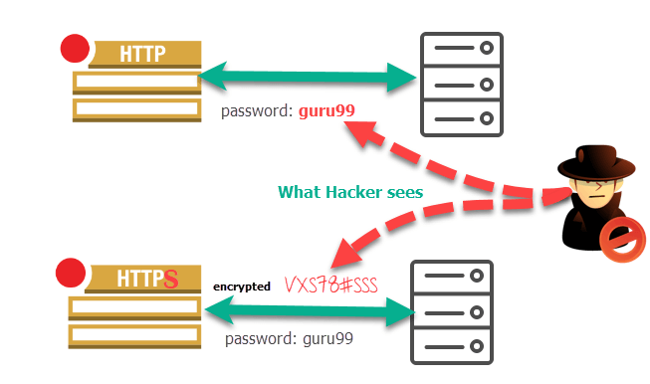

Difference between HTTP and HTTPS protocol

## Difference Between HTTP and HTTPS

The below table demonstrates what is difference between HTTP and HTTPS: